Design and Development of an AI-Enabled Web-Based Eyewear Inventory and E-Commerce Management System (iWear) with an AI Business Insights Assistant
MSc Masters Project Specification
Supervisor: Tariq Alsboui Date: 17-Feb-2026

1. Abstract
The rapid advancement of digital technologies and e-commerce platforms has significantly transformed modern retail operations. Small and medium-sized enterprises (SMEs) increasingly rely on web-based systems to manage inventory, sales, and customer relationships. Despite this shift, many optical and eyewear retailers still depend on manual processes or basic spreadsheet-based solutions, which result in inefficiencies, data inaccuracies, poor stock control, and limited visibility of business performance.
This project proposes the design and development of an AI-enabled web-based Eyewear Inventory and E-Commerce Management System, named iWear. The system integrates inventory management, product catalog management, online ordering using a cash-on-delivery model, and eyewear-specific customization, including frame selection, lens options, and prescription data input. In addition, the system includes an AI Business Insights Assistant that allows store owners to retrieve business reports such as daily sales, profit, and best-selling products using natural-language queries.
The project will adopt an iterative and incremental development methodology encompassing requirements analysis, system design, implementation, testing, and evaluation. Modern web technologies will be employed to ensure scalability, usability, and security. The expected outcome is a functional prototype that demonstrates the effective application of computing and artificial intelligence techniques to address real-world challenges faced by eyewear retailers.
In addition to inventory management, the iWear system incorporates a customer-facing e-commerce module that supports eyewear-specific customisation, including frame selection, lens options, and prescription data input. Furthermore, the system integrates an AI Business Insights Assistant designed to provide store owners with accessible business intelligence through natural-language queries. Together, these components form a unified platform that supports operational efficiency, customer experience, and data-driven decision-making within the eyewear retail domain.

3. Justification and Overall Aim

3.1 Justification
The growth of e-commerce has transformed the way retail businesses engage with customers, offering greater convenience and wider market reach. However, not all retail sectors are equally supported by generic e-commerce platforms. Eyewear retail presents specific challenges due to the need for product customisation, prescription handling, and accurate representation of complex product attributes. Many optical retailers attempting to sell products online rely on standard e-commerce systems that are not designed to support these requirements.
Generic e-commerce platforms typically provide basic product configuration options, such as size or colour, but lack built-in support for prescription-based customisation. As a result, eyewear retailers often depend on manual communication methods, such as phone calls, messaging applications, or external forms, to collect prescription details from customers. This fragmented approach is inefficient, time-consuming, and prone to errors, increasing the likelihood of incorrect orders and delayed fulfilment.
User experience is a critical factor influencing online purchasing behaviour. Research indicates that complex or unclear ordering workflows frequently lead to cart abandonment and reduced customer satisfaction. For eyewear products, where purchasing involves multiple steps such as frame selection, lens options, and prescription input, poorly designed interfaces significantly increase cognitive load for users. When customers are unable to clearly understand or complete the customisation process, they are more likely to abandon the purchase or submit incorrect information.
Furthermore, inaccurate capture of customer requirements can result in incorrect orders and higher return rates. Returns not only incur financial costs for retailers but also negatively affect customer trust and brand reputation. For small and medium-sized optical retailers, these inefficiencies can have a substantial impact on business sustainability.
The justification for this individual project component lies in the need for a dedicated, domain-specific e-commerce module that supports the complete eyewear purchasing workflow. By designing a user-centred frontend interface and integrating it with well-defined backend application programming interfaces (APIs), the proposed solution aims to simplify the ordering process, reduce errors, and improve overall usability. This approach directly addresses the limitations of generic e-commerce platforms and aligns system functionality with the practical requirements of eyewear retail.

3.2 Overall Aim
The overall aim of this individual project component is to design and develop a web-based e-commerce module that supports eyewear-specific customisation, secure prescription data input, and seamless order placement, thereby improving user experience and enabling efficient online sales for optical retail businesses.

4. Objectives
The objectives of this individual project component are structured to be specific, measurable, achievable, relevant, and time-bound (SMART). Together, they support the systematic design, implementation, and evaluation of the e-commerce module within the iWear system.
The first objective is to analyse user experience requirements for online eyewear purchasing. This involves identifying user expectations, common usability challenges, and pain points associated with existing eyewear e-commerce platforms, particularly those related to product customisation and prescription input.
The second objective is to design intuitive user interfaces that support efficient product browsing and customisation. This objective focuses on creating clear navigation structures, consistent layout designs, and visual cues that guide users through the purchasing process with minimal cognitive effort.
Another objective is to implement eyewear-specific customisation workflows, including frame selection and lens options. These workflows are designed to ensure that users complete required steps in a logical sequence, reducing confusion and the likelihood of incomplete or incorrect orders.
The project also aims to develop secure and validated forms for prescription data input. This objective ensures that customer-provided information is complete, accurate, and formatted correctly before order submission. Input validation contributes to reducing order errors and unnecessary manual follow-up by retailers.
In addition, the project seeks to implement cart and checkout functionality using a cash-on-delivery model. This objective supports practical deployment in SME environments where online payment gateways may not be available or preferred.
The integration of frontend components with backend application programming interfaces (APIs) is another key objective. Successful integration ensures reliable data exchange between the user interface and server-side services.
Finally, the project aims to test the e-commerce module for usability, correctness, and reliability. This objective is evaluated through functional testing and usability assessments to confirm that users can complete the purchasing process efficiently and accurately.

5. Literature Review
E-commerce systems have been widely studied for their role in improving accessibility, operational efficiency, and market reach for retail businesses. As online shopping becomes a dominant sales channel, researchers increasingly emphasise the importance of usability, clarity of information, and streamlined purchasing workflows. Well-designed e-commerce platforms not only improve transaction efficiency but also influence customer trust and long-term engagement.
User experience (UX) design has been identified as a critical success factor in e-commerce adoption. Nielsen (2012) argues that usability directly affects a user’s ability to complete tasks effectively and with minimal frustration. In online retail environments, poor usability often results in cart abandonment and reduced conversion rates. Studies consistently show that customers are more likely to complete purchases when interfaces are intuitive, visually consistent, and easy to navigate.
UX design becomes even more important when products require customisation. For customised products, guided configuration interfaces play a key role in reducing user error and cognitive load. Research suggests that step-by-step workflows and validation-driven forms significantly improve accuracy and customer satisfaction. Chaffey (2019) notes that digital interfaces which clearly guide users through complex processes directly influence consumer trust and purchase intention, particularly in scenarios where users must provide detailed input.
In the context of eyewear retail, e-commerce presents additional challenges compared to standard retail products. Purchasing eyewear typically involves multiple stages, including frame selection, lens type configuration, and prescription data entry. Generic e-commerce platforms are primarily designed for simple products with limited configuration options, such as size or colour. As a result, they often fail to support the structured input required for prescription-based products.
Laudon and Traver (2021) argue that domain-specific e-commerce systems are better suited to handling complex product configurations. Their work highlights that platforms designed with a clear understanding of domain requirements are more effective at reducing user error and improving overall system usability. In eyewear retail, the lack of prescription-aware workflows frequently forces retailers to rely on manual communication methods, such as follow-up emails or phone calls, to collect missing information. This fragmented process increases the likelihood of incorrect orders and delays in fulfilment.
Frontend technologies also play a significant role in enabling effective UX design. React-based frontend architectures are widely adopted in modern web applications due to their component-based structure, reusability, and responsiveness. Research indicates that component-based frameworks support consistent interface design and facilitate rapid development of interactive user interfaces. These characteristics are particularly valuable in e-commerce systems that require dynamic form handling and real-time feedback during the ordering process.
Despite extensive research on general e-commerce usability, relatively limited attention has been given to highly customised retail products that require structured and validated user input. Many existing platforms prioritise visual product presentation and marketing features over guided configuration workflows. While such approaches may be suitable for standard consumer goods, they increase the likelihood of user error when applied to products that involve technical or medical information, such as prescription-based eyewear.
Studies also suggest that insufficient validation during data entry contributes to incorrect orders and increased return rates. For SMEs, high return rates can significantly affect profitability and operational efficiency. Consequently, there is a growing need for e-commerce systems that balance visual appeal with functional accuracy and structured user guidance.
This project builds upon existing e-commerce and UX literature by applying established usability and interface design principles to the specialised context of eyewear retail. By focusing on guided customisation workflows, validated prescription input forms, and clear user interaction patterns, the proposed system addresses a gap in current e-commerce solutions. The literature indicates that domain-specific, user-centred design approaches are essential for improving accuracy, usability, and customer satisfaction in customised e-commerce environments, particularly for small and medium-sized optical retailers.

6. Methodology
An iterative and incremental development methodology is adopted for the development of the e-commerce module within the iWear system. This approach is particularly appropriate for user-centred system development, as it allows continuous refinement of interface design and functionality based on testing outcomes and usability feedback. By developing the system in incremental stages, usability issues can be identified early and addressed before progressing to more complex features.
The iterative methodology supports flexibility, enabling design decisions to evolve as user requirements and technical constraints become clearer. This is especially important for eyewear e-commerce systems, where user interaction and data accuracy directly influence order correctness and customer satisfaction.

6.1 Frontend Development
The frontend of the e-commerce module is developed using React, a widely adopted JavaScript library for building interactive user interfaces. React is selected due to its component-based architecture, which enables the development of reusable, modular interface components. This approach improves maintainability, supports consistent interface design, and allows individual components to be tested and refined independently.
Key frontend pages include product listings, product detail views, customisation forms, shopping cart, and checkout interfaces. Each page is designed with a clear layout and intuitive navigation structure to minimise user confusion. Responsive design principles are applied to ensure that the system functions effectively across different devices, including desktops, tablets, and mobile phones.
Styling and layout decisions prioritise clarity and accessibility, ensuring that product information and customisation options are presented in a structured and user-friendly manner.

6.2 Customisation Workflow
A structured customisation workflow is implemented to guide users through the eyewear purchasing process. The workflow is designed as a step-by-step sequence, beginning with frame selection, followed by lens options, and concluding with prescription data entry. This sequential approach reduces cognitive load and ensures that users complete all required steps in the correct order.
Each stage of the workflow includes contextual guidance to help users understand available options and their implications. Mandatory steps are clearly indicated to prevent incomplete submissions. By enforcing a guided process, the system reduces the likelihood of missing or incorrect input, which is a common issue in generic e-commerce platforms.
The workflow design is informed by usability principles that emphasise clarity, feedback, and error prevention. This approach improves both accuracy and user confidence during the purchasing process.

6.3 Backend Integration
Frontend components communicate with backend services through RESTful application programming interfaces (APIs). These APIs enable secure and structured data exchange between the user interface and server-side services, including product information retrieval, order submission, and stock validation.
Error handling mechanisms are implemented to manage failed requests, invalid responses, or connectivity issues. Clear error messages are displayed to users when necessary, ensuring transparency and maintaining trust. Secure data transmission protocols are used to protect sensitive information, particularly prescription data entered during the ordering process.
The separation of frontend and backend components supports modular development and simplifies future system extensions or modifications.

6.4 Testing Strategy
A comprehensive testing strategy is employed to evaluate the usability, correctness, and reliability of the e-commerce module. Functional testing is conducted to verify that all system features operate as intended, including product selection, customisation workflows, cart functionality, and checkout processes.
Usability testing focuses on evaluating how effectively users can complete the purchasing process. Test scenarios simulate realistic user interactions, identifying potential usability issues such as unclear navigation, confusing input fields, or excessive steps. Feedback from these tests informs iterative refinements to interface design and workflow structure.
Testing outcomes are documented and analysed to ensure that the system meets defined objectives related to accuracy, efficiency, and user satisfaction.

6.5 Client-Side Validation and User Interaction Handling
Client-side validation plays a critical role in ensuring data accuracy and improving user experience within the e-commerce module. Validation mechanisms are implemented to verify that users provide complete and correctly formatted information before proceeding to checkout. This is particularly important for prescription data, where incomplete or incorrect input can result in unusable products.
Validation rules include checks for mandatory fields, acceptable value ranges, and logical consistency between inputs. By handling validation at the client level, the system provides immediate feedback, allowing users to correct errors without submitting incorrect data to the server.
Interactive feedback mechanisms, such as real-time error messages, visual indicators, and contextual guidance, are used to support user interaction. These features reduce frustration, prevent repeated errors, and contribute to a smoother purchasing experience. Additionally, client-side validation reduces unnecessary backend processing and minimises incorrect order submissions.

6.6 Ethical and Practical Considerations
The e-commerce module processes prescription-related information, which requires careful handling. Although the project is academic in nature, secure data handling practices are applied, including controlled access and secure data transmission. User data is collected only for functional purposes and is not retained beyond system requirements.
Practical constraints, such as limited development time and academic scope, influence design decisions. As a result, the system prioritises functional correctness and usability over advanced features such as online payment gateways or recommendation systems.

7. System Design
The system will follow a three-tier architecture consisting of:
- Presentation Layer: React-based frontend interface
- Application Layer: Python-based backend services
- Data Layer: PostgreSQL relational database

7.1 Module Descriptions
- Inventory Management Module: Manages products, stock updates, and low-stock alerts.
- Eyewear Customization Module: Handles frame selection, lens selection, and prescription entry.
- Order Management Module: Manages cart operations, order placement, and order history.
- AI Business Insights Module: Processes natural-language queries and generates business reports.

7.2 Security and Data Management
Security is a critical aspect of web-based systems. The proposed system will implement user authentication and role-based access control to restrict system access. Sensitive information such as user credentials will be securely stored using hashing techniques. Database access will be controlled through secure API endpoints to prevent unauthorized access.
Data integrity will be maintained through validation mechanisms and transaction management. Regular backups will be considered to minimize the risk of data loss.

8. Evaluation Strategy
The e-commerce module will be evaluated using the following criteria:
- Task completion time for common user actions
- Accuracy of captured customization and prescription data
- Usability feedback from test users
- Reliability of frontend-backend integration
Evaluation results will be analysed to determine whether the objectives of this component have been achieved.

9. Work Plan
This Gantt chart outlines the development of the eyewear-specific e-commerce interface. The project begins with user experience analysis to understand the challenges associated with online eyewear purchasing. Wireframing and interface design ensure that customization workflows are intuitive and user-friendly.
Frontend development focuses on product browsing, customization forms, and checkout processes. Special attention is given to prescription input and validation to reduce user error. Backend integration ensures seamless communication between the frontend and server-side services.
Usability testing is conducted to evaluate task completion efficiency and data accuracy. The final phase focuses on evaluation and documentation, ensuring that the e-commerce module delivers a reliable and accessible online shopping experience.
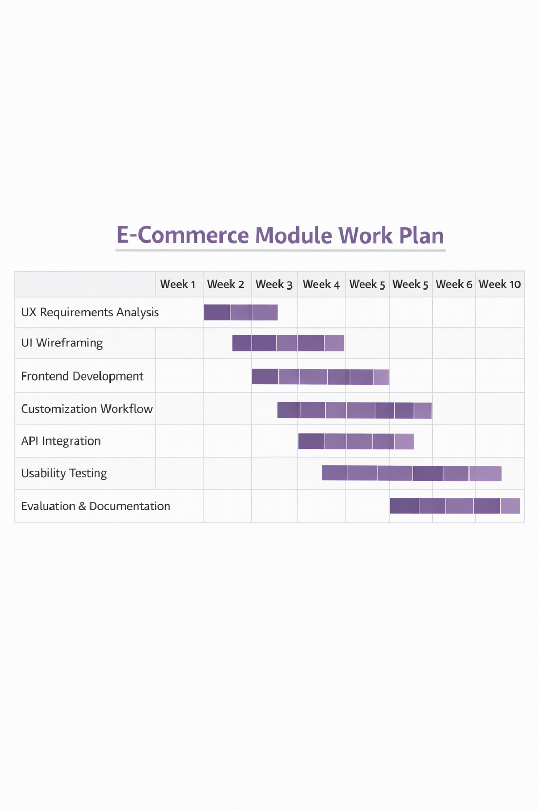

10. Ethical Considerations
The e-commerce module collects prescription data, which requires careful handling. Input validation and secure data transmission will be implemented to protect user information. All data will be used strictly for academic purposes.

11. Risks and Limitations
Potential risks include usability challenges and integration issues with backend services. These risks will be mitigated through iterative testing and simplified interface design. The prototype does not include online payment gateways, focusing instead on functional correctness.

12. Conclusion
This individual component focuses on the development of a dedicated e-commerce interface for eyewear retail. By supporting customization and prescription workflows, the module aims to improve customer experience and enable efficient online order processing.

References
(Harvard – Cite Them Right)
Nielsen, J. (2012) Usability Engineering. San Francisco: Morgan Kaufmann.
Chaffey, D. (2019) Digital Business and E-Commerce Management. 7th edn. Harlow: Pearson Education.
Heizer, J., Render, B. and Munson, C. (2020) Operations Management: Sustainability and Supply Chain Management. 13th edn. Harlow: Pearson.
Laudon, K.C. and Traver, C.G. (2021) E-Commerce: Business, Technology, Society. 16th edn. Harlow: Pearson Education.
Turban, E., Pollard, C. and Wood, G. (2018) Information Technology for Management: On-Demand Strategies for Performance, Growth and Sustainability. 11th edn. Hoboken: Wiley.
Chen, H., Chiang, R.H.L. and Storey, V.C. (2012) ‘Business Intelligence and Analytics: From Big Data to Big Impact’, MIS Quarterly, 36(4), pp. 1165–1188.
Rouse, M. (2020) Inventory Management System. Available at: https://www.techtarget.com (Accessed: 15 January 2026).
PostgreSQL Global Development Group (2024) PostgreSQL Documentation. Available at: https://www.postgresql.org/docs/ (Accessed: 15 January 2026).
Flask Documentation (2024) Flask Web Framework. Available at: https://flask.palletsprojects.com (Accessed: 15 January 2026).
React Documentation (2024) React – A JavaScript Library for Building User Interfaces. Available at: https://react.dev (Accessed: 15 January 2026).

